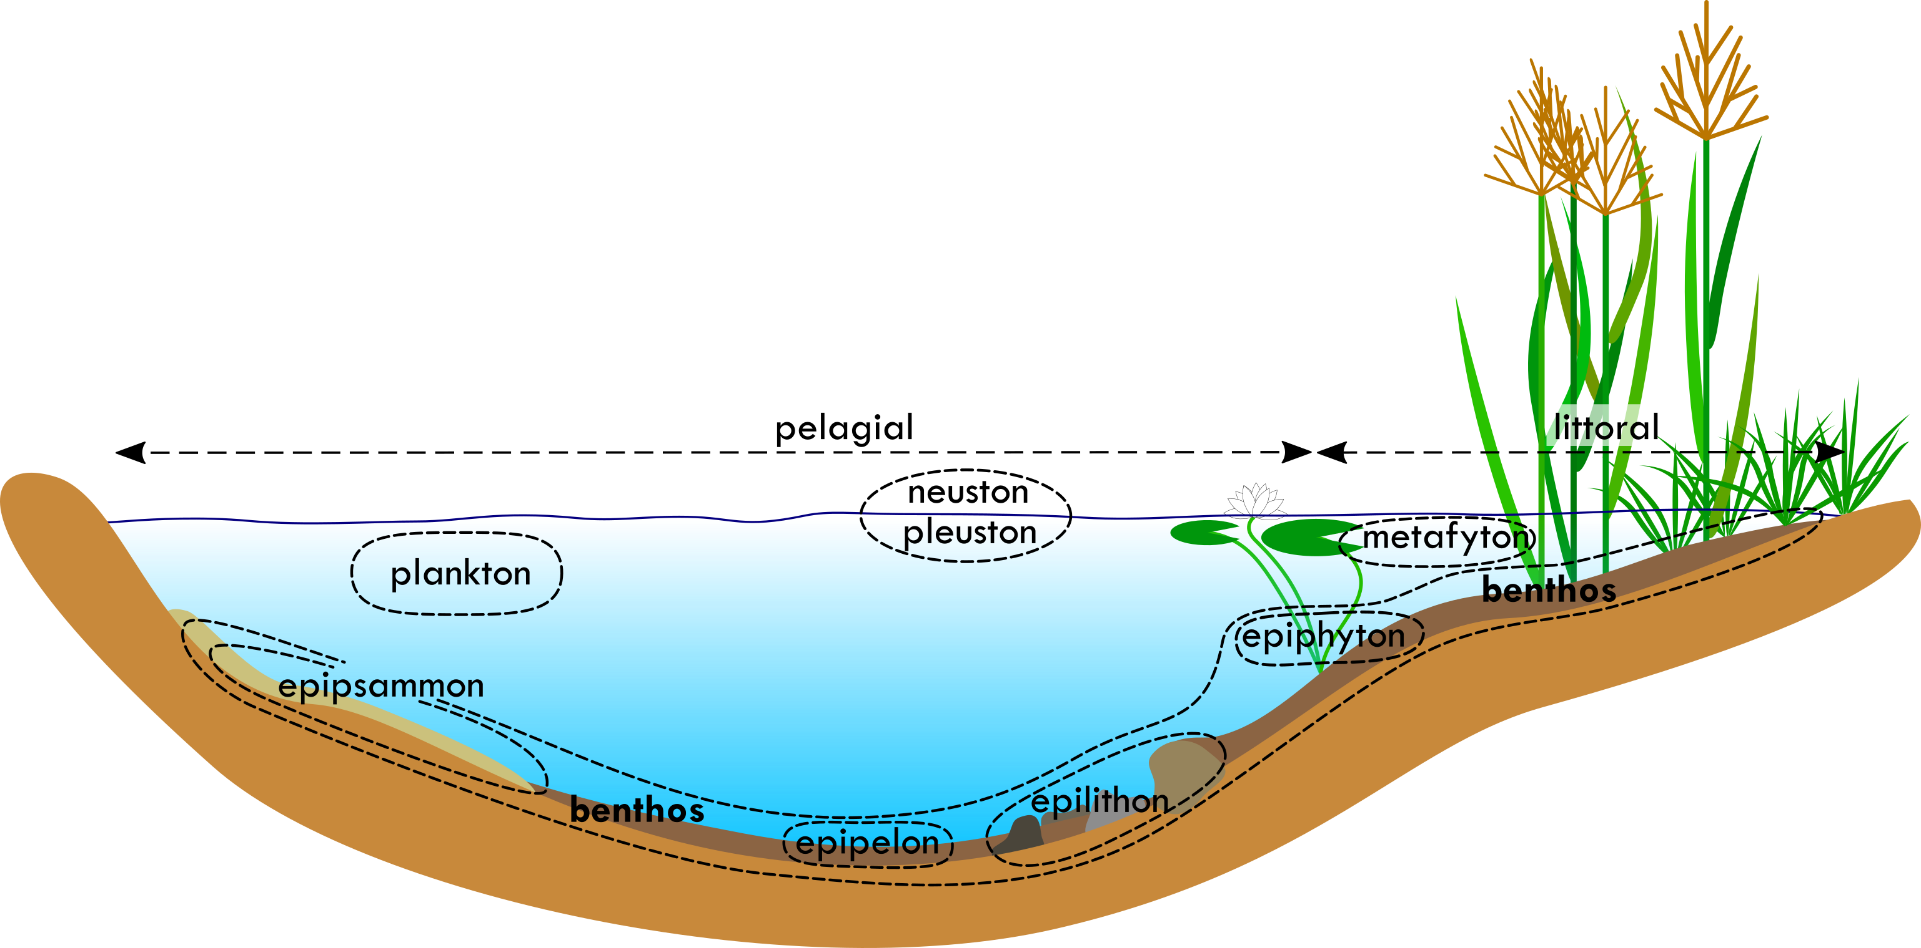
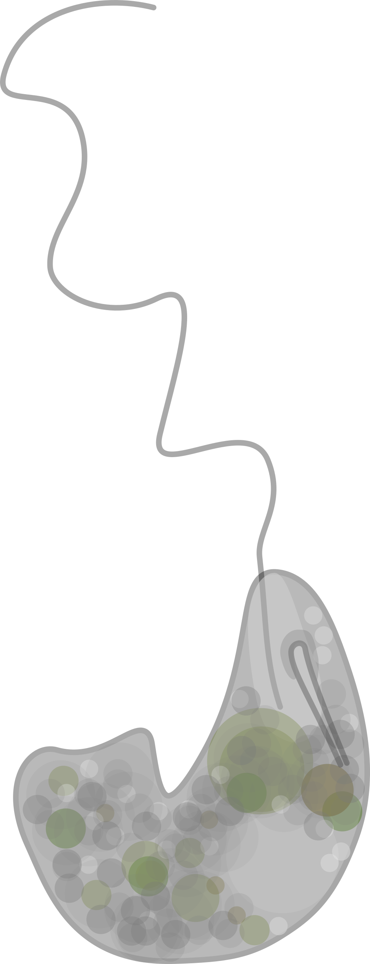
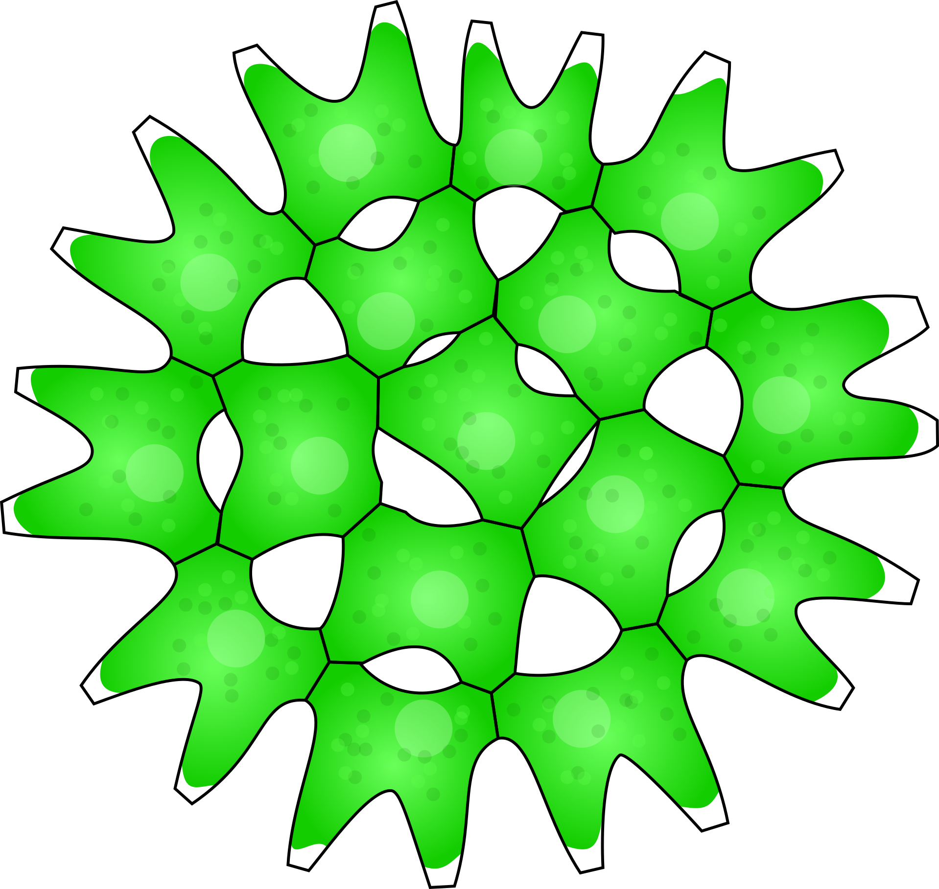
Benthos is traditionally referred to as a community of bottom-dwelling organisms. It is mainly composed of the epipelon. It is difficult to define it precisely and distinguish it from the periphyton, which is why both communities are very similar – diatoms also play a major role here. Since a lot of organic matter settles to the bottom, there are many heterotrophs in the benthos.
Periphyton, or growths, is a community of organisms living sessile on submerged substrates. Depending on the type of substrate, we distinguish different types of growths: epipelon between fine particles of mud or sand, epiphyton on plants, epilithon on stones, epipsammon on sand and epizoon on animals. The main group of periphyton is diatoms.
Plankton is a community of organisms floating freely in the water mass.
The term phytoplankton refers to cyanobacteria and algae, while the term zooplankton refers to heterotrophic protozoa, crustaceans, rotifers, etc.

Both the species communities and the sizes of the depicted taxa are only very approximate and illustrative.
Trophic state of an ecosystem simply means its nutrient content. The main nutrients are dissolved phosphorus and nitrogen. Eutrophic bodies are those that have an excess of nutrients (most ponds), mesotrophic are at an intermediate level of nutrient content (e.g., some reservoirs, better quality ponds), and oligotrophic have only a minimum of nutrients (this includes peat bogs, preserved flooded sand pits and quarries, lakes, etc.). Intermediate stages are called combinations of the names of both stages (e.g., meso-eutrophic, oligo-mesotrophic). The trophic status of a biotope is also closely associated with the taxonomic composition of the community inhabiting it.
Sample examples
On the following pages you will find examples of what samples of different communities from different habitats might look like. In order to understand
the following pages correctly, it is important to keep in mind that:

